Software Requirements Specification (SRS) for Snake And Ladder Project

*Baseline version 0.1*

*Issued on : August 27, 2012*

Issued by : Andro, UPH.

Issued for : Robertus Hudi

Change History

|  |  |  |  |
| --- | --- | --- | --- |
| Version | Date | Author | Changes |
| 0.1 | August 27, 2012 | Andro Eliezer | 0.1 |
|  |  |  |  |

Document Approval

The following Software Requirements Specification has been accepted and approved by the following :

|  |  |  |  |
| --- | --- | --- | --- |
| Name | Title | Date | Signature |
| Andro | Project Manager |  |  |
| Robertus Hudi | Client |  |  |
|  |  |  |  |

**Table of Contents**

1 SCOPE................................................................................................................................. 3

1.1 SCOPE..........................................................................................................................

1.2 PURPOSE .......................................................................................................................... 3

1.3 DEFINITIONS, ACRONYMS AND ABBREVIATIONS.................................................................. 3

1.4 REFERENCE DOCUMENTS................................................................................................... 3

1.5 DOCUMENT OVERVIEW...................................................................................................... 3

2 GENERAL DESCRIPTION.................................................................................................... 4

2.1 SYSTEM PERSPECTIVE ....................................................................................................... 4

2.2 SYSTEM FUNCTIONS.......................................................................................................... 4

*2.2.1 Class hierarchy........................................................................................................... 4*

2.3 USER CHARACTERISTICS.................................................................................................... 4

2.4 CONSTRAINTS ................................................................................................................... 5

2.5 ASSUMPTIONS AND DEPENDENCIES..................................................................................... 5

3 OVERVIEW......................................................................................................................... 6

3.1 EXTERNAL INTERFACE REQUIREMENTS............................................................................... 6

*3.1.1 User Interfaces ........................................................................................................... 6*

*3.1.2 Hardware Interfaces .................................................................................................... 6*

*3.1.3 Software Interfaces ...................................................................................................... 6*

*3.1.4 Communication Interfaces............................................................................................. 6*

3.2 FUNCTIONAL REQUIREMENTS ............................................................................................ 6

*3.2.1 Dialogue Management CSCI (DM) ................................................................................. 6*

*3.2.2 Mapping CSCI (MP) .................................................................................................... 7*

*3.2.3 Artifact Management CSCI (AM).................................................................................... 8*

*3.2.4 Creature and Fight Management CSCI (CFM)................................................................ 10*

3.3 PERFORMANCE REQUIREMENTS ....................................................................................... 11

3.4 DESIGN CONSTRAINTS ..................................................................................................... 11

*3.4.1 Standards Compliance................................................................................................ 11*

3.5 SOFTWARE SYSTEM ATTRIBUTES ..................................................................................... 11

*3.5.1 Reliability ................................................................................................................ 11*

*3.5.2 Availability .............................................................................................................. 11*

*3.5.3 Security and Privacy .................................................................................................. 11*

*3.5.4 Maintainability ......................................................................................................... 11*

*3.5.5 Portability................................................................................................................ 11*

*3.5.6 Safety...................................................................................................................... 12*

*3.5.7 Training-related Requirements..................................................................................... 12*

*3.5.8 Packaging Requirements............................................................................................. 12*

3.6 OTHER REQUIREMENTS.................................................................................................... 12

4 APPENDICES..................................................................................................................... 13

5 INDEX ............................................................................................................................... 14

List of Figures

# List of Figures

**Use Case.**….……………………..........................……………………………............................

**Sequence Diagram 1**…..……………………..........................……………………………........

**Chapter 1**

**INRODUCTION**

* 1. **Purpose**

The purpose of this documents is to introduce the required software for implementing the function of Two-Dimensional Array to create Snake and Ladder’s games and improved the function to become more Reusable Resources for other projects.

* 1. **Scope*:***

*Snake and Ladder game is a race game between players which moves for each random numbers rolled ,and through boxes that mapped to the goal. The game is named Snake and Ladder because it has snakes as the hurdles and Ladders as the Shortcuts.*

*The game product will be able to be played by multiplayer user. The source code is divided into many function that may reusable for other games as resources.*

*List of project code Benefits :*

* *Playable Games*
* *Multiplayer is available*
* *Reusable resources*
* *Quality of Source Code*
* *Learnable Resources*

*This Project does not include any Hardwares parts. This Project is focus on the advantages of using Two-Dimensional array for Board Games.*

* 1. **Definitions, Acronyms, and Abbreviations**

SRS: Software Requirement Specifications

GUI: Graphical User Interface.

JRE: Java Runtime Environment.

Use Case: Methodology used in system analysis to identify, clarify, and organize system requirements.

Class Diagram: An illustration of the relationships and source code dependencies among classes in the Unified Modeling Language (UML).

Sequence Diagram: Show the interactions between objects in the sequential order that those interactions occur.

State Diagram: Diagram used in computer science to describe the behavior of a system considering all the possible states of an object when an event occurs

* 1. **References**

# Two-Dimensional Array. Readed at 21 November 2014 <<https://processing.org/tutorials/2darray/>> Liang, Daniel. Introduction to Java Programming, Comprehensive Version (9th Edition) : 12 March 2012

* 1. **Overview**

The first section of the SRS introducing what are our project that is a Snake And Ladder’s Project, Second section of the SRS discussing about our project description, Third section of the SRS discussing specific requirement about our project. Fourth section of the SRS discussing about our Analysis model and the last section discussing about change management process.

Chapter 2

GENERAL DESCRIPTION

1. **System Perspective**

Snake and Ladder project idea is to create a two-dimensional array for storing the players as an object in the board. Two-Dimensional Array represents all the board’s boxes in Snake and Ladder games. It reusable to other board game.

1. **System Functions**

At Java, As the Two-Dimensional array represent as the board’s Boxes. As a[n][m] , n represent the row and m represent the colum of the board game. For example a[1][2] which is the box at column 2 and row 1. IF the player were inside of the box, or were moved there. Then the array value will be 1 for player one or 2 for player two, and other boxes or arrays value is 0. For example if the player one were in the colum 3, row 4 then a[4][3] = 1.

1. **User Characteristics**

User : Play game , Reuse coding

1. **General Constraints**

The player can play the game after clicking start button game  
The functions that reusable only for similar projects

1. **Assumptions and Dependencies**

*This subsection of the SRS should list each of the factors that affect the requirements stated in the SRS. These factors are not design constraints on the software but are, rather, any changes to them that can affect the requirements in the SRS. For example, an assumption might be that a specific operating system will be available on the hardware designated for the software product. If, in fact, the operating system is not available, the SRS would then have to change accordingly.*

Chapter 3

SPECIFIC REQUIREMENTS

1. **External Interface Requirements**

Requirements :

* Netbeans (IDE)
* Windows (OS)
* Java,Swing(Language, Library)
* Computer(PC)

1. **Functional Requirements**

*The Game must able to view condition  
The Game must able to be played well.*

## 3.3 Use Cases

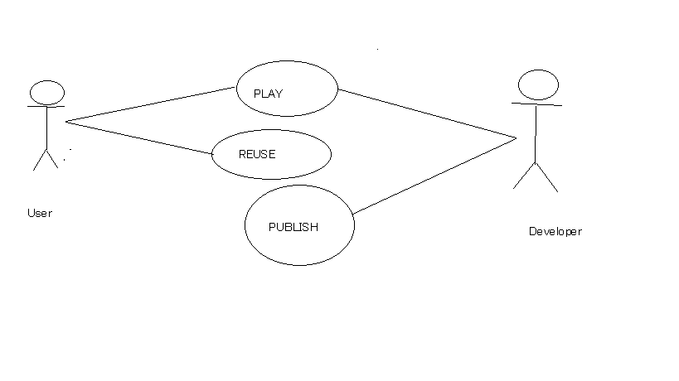

1. **Non-Functional Requirements**

*The game need to update the location of players through array*

*The game need to show when the game start or end, or when the snake or ladder function is working*

1. **Design Constraints**

Java Programming Language

Using Graphical User Interface

2D Graphics.

Chapter 4

ANALYSIS MODELS

*List all analysis models used in developing specific requirements previously given in this SRS. Each model should include an introduction and a narrative description. Furthermore, each model should be traceable the SRS’s requirements.*

1. **Sequence Diagrams**

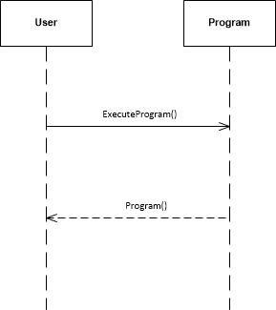

Play game and system give respond

Chapter 5

CHANGE MANAGEMENT PROCESS

## 5.1 Actor

The Source code of Snake and Ladder can be altered and edited as user’s wish and its free.

1. **Appendices**

*Appendices may be used to provide additional (and hopefully helpful) information. If present, the SRS should explicitly state whether the information contained within an appendix is to be considered as a part of the SRS’s overall set of requirements.*

1. **Appendix 1**

Liang, Daniel. Introduction to Java Programming, Comprehensive Version (9th Edition) : 12 March 2012

1. **Appendix 2**

Two-Dimensional Array. Readed at 21 November 2014 <<https://processing.org/tutorials/2darray/>>